Đề 5:

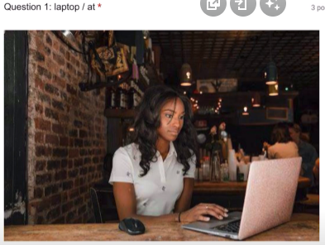

A woman is looking at a laptop in the coffee shop.

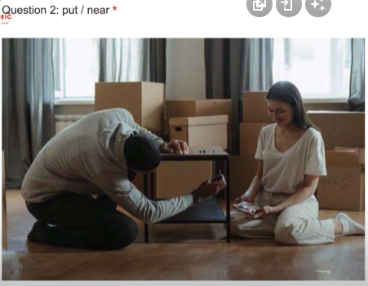

A man is putting something under the table near a woman.

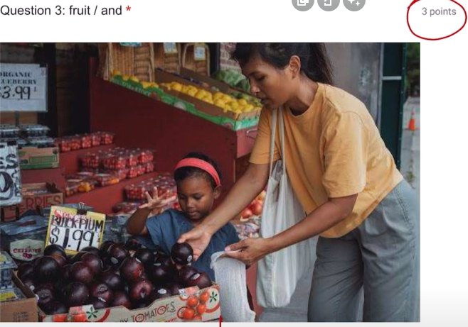

A woman and her daughter are buying some fruits.

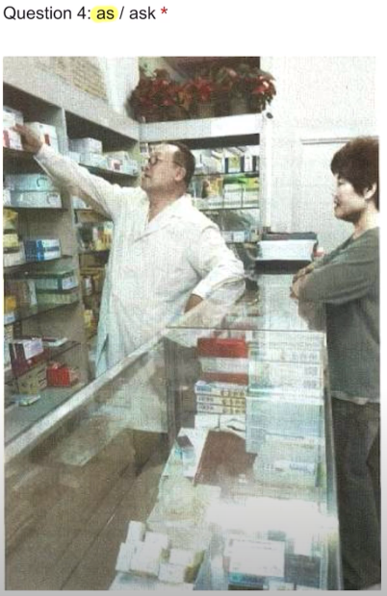

A doctor is taking something as a woman asks him to do.

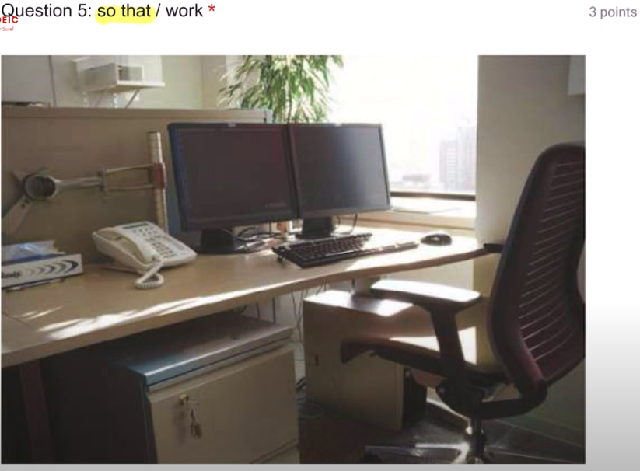

Because today is Sunday so that there are not any people work.